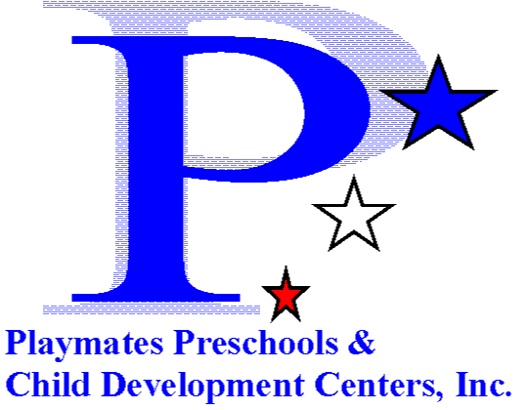
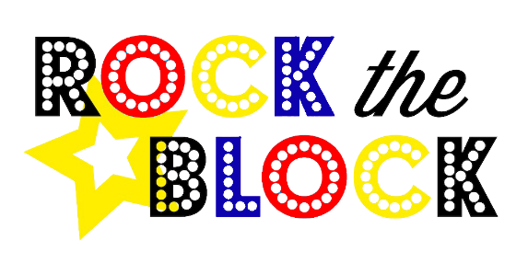
We would like to invite you to participate in the Second Annual “Rock the Block”
Playmates is hosting an event that will help sponsor economically disadvantaged children to have a safe place to go during the summer. This event will have vendors from local agencies, baked goods, food, prizes, activities for the children, and an inflatable. All proceeds of the event will go towards Summer Camp Passes for at-risk children.
Save the Date!
When: Friday, May 17th, 6pm-8pm Where: Ceredo Plaza Parking Lot
Vendor set-up 5pm-5:45pm 420 W 4th St,
Ceredo, WV 25507
If you’re interested in hosting a table at this event or if you’d like to provide materials for distribution, please complete and email or fax form by May10 ^{th} to:
Courtney Long
courtneypaige_2008@yahoo.com
Phone: 304-908-3368
Fax: 304-908-3386
- - - - - - - - - - - - - - - - - - - - - - - - - - - - - - - - - - - - - - - - - - - - - - - - - - - - - - - - - - - - - - - - - -
Organization:___________________________________________________________________
Contact Person:_________________________________________________________________
Phone & Email___________________________________________________________
Please briefly describe the resources or information you’ll be providing at your table:_________________________________________________________________________
______________________________________________________________________________
Table Donation Fee: Minimum donation of $25 per table, all proceeds will go towards Summer Camp Passes and Activities for At Risk Children. If you need us to provide a table and chairs just let us know on this form.

