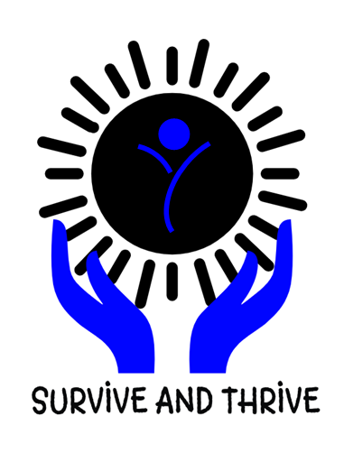
Child Abuse Prevention
Awareness Day
You are invited to participate in this special event hosted by
River Park Hospital!
We would love to join efforts with you, and other agencies in our area, to bring awareness of Child Abuse Prevention to our community. Your participation can help provide our families with useful resources to help prevent abuse, and get help for those who have been affected by abuse.
1230 6th Avenue Huntington, WV 25701 304.526.9111
River Park Hospital

SATURDAY, APRIL 13, 2019
Barboursville Park, Pavilion #9
11am – 3pm

YES, I WILL PARTICIPATE!
Organization Name: _______________________________________________
Contact Name: _____________________________________________________
Address: ____________________________________________________________
Phone: ___________________________ Fax: ____________________________
Email: ______________________________________________________________

