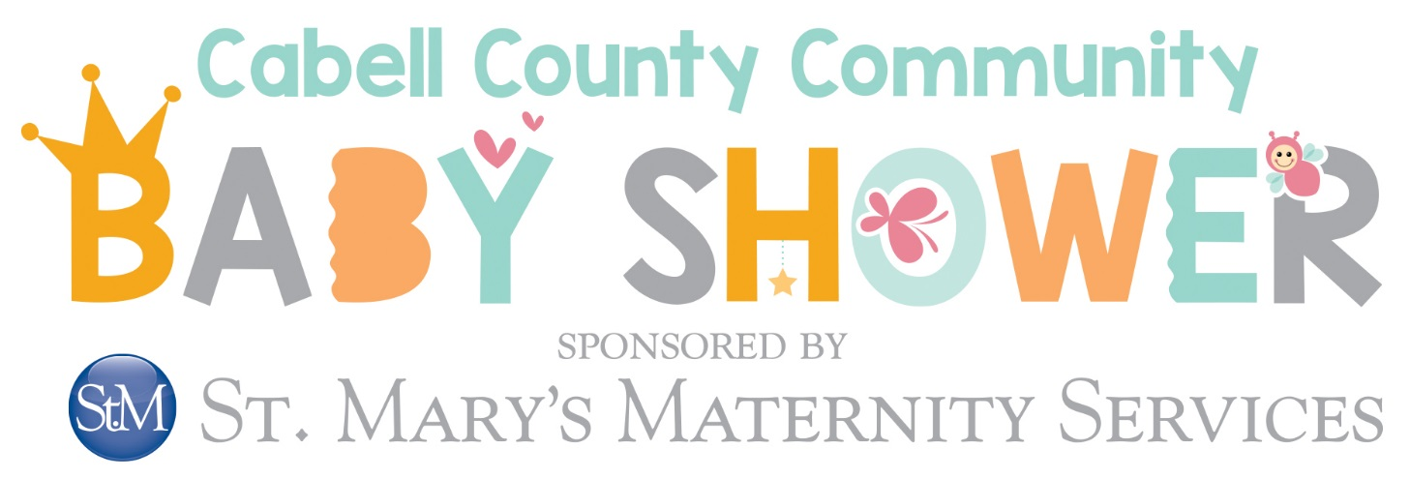

DOOR PRIZE WISH LIST

HERE ARE A FEW OF OUR MOST-REQUESTED BABY ITEMS.
WE WOULD LOVE TO PROVIDE AS MANY OF THESE AS POSSIBLE AT THIS YEAR’S SHOWER!

- Pack and Play
- Travel System Stroller
- Baby Swing
- Car Seat
- Double Electric Breast Pump
- Baby Monitor
- Crib
- High Chair
- Baby Gate & Home Safety Supplies
- Bouncer or Activity Mat
- Exersaucers or Walkers
- Baby Carrier
- Baby Bath, Faucet Cover, & Bath Thermometer
- Nursing Pillow, Cover, & Breastfeeding Supplies

