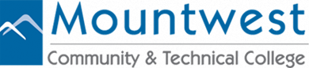
MCTC Resource Fair

Mountwest Community & Technical College’s mission statement is to prepare students for careers, civic responsibility and lifelong learning. We at Mountwest CTC want to provide students information to access community resources. We want our college students to know the types of services that can be utilized while they focus on obtaining their education. Mountwest Community & Technical College is dedicated to providing a variety of resources on campus and off campus, and believe that becoming familiar with community agencies and organizations will aid them in transitioning from becoming dedicated students and community members. Mountwest CTC would like you to be a part of this resource fair.
Where: Mountwest Community & Technical College Main Lobby
When: March 14, 2018
Time: 10:00 A.M. – 2:00 P.M.
By attending the resource fair your organization can market services you provide, along with networking with other organizations. The resource fair is free. The deadline date to register is March 1, 2018.
If you have questions and/or would like to represent your organization, please register by emailing Mary Klein at (304) 710-3367 or kleinm@mctc.edu, or Jill Goheen at (304) 710-3368, kelleyj@mctc.edu.

