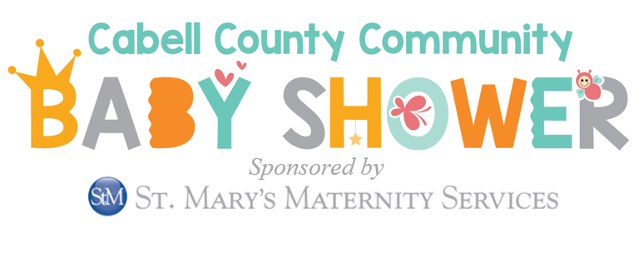

**Wish List**

***Please help us fill 100 baskets with each of the following:***



**Baby Blankets Thermometers**

**Baby Lotion Baby Wash**

**Diaper Cream/Ointment Newborn size socks**

**Baby Shampoo Baby Wipes**

**Caps and Booties Diapers-Size N or 1**

**Books Bibs**

**Pacifiers Outlet Covers Teethers or Rattles**

*If interested in making a donation, please let us know by March 15th****.***

*Please contact: April Knight at 304-523-9587 ext. 302 or* [*april@teamwv.org*](mailto:april@teamwv.org)