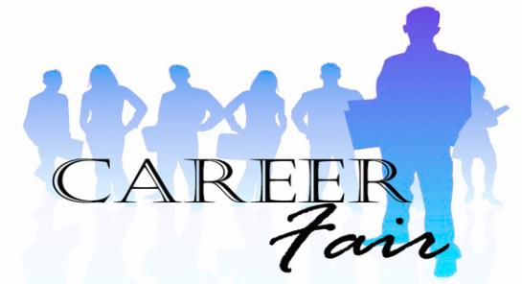
“2015 Fall Career Fair”
Sponsored by The River Cities Council for Persons with Disabilities
Big Sandy Superstore Arena
1 Civic Center Plaza, Huntington, WV 25701
October 1, 2015 10:00 am – 1:00 pm
Employers, Schools, and Service Providers Welcome!

Send response to: Lisa.D.Wayman@wv.gov or Timothy.M.Bowens@wv.gov
fax completed form to (304) 528 5591 Attention Lisa Wayman or Tim Bowens
for more information call at (304) 528-5585 ask for Tim or Lisa

Company Name:_________________________________________________________
Address: _______________________________________________________________
Phone: _______________________ Email: ________________________________
Representatives: 1. _______________________________________________________
2. ________________________________________________________
One Table will be provided with 2 chairs (Bring your own tablecloth)
Do you need electricity Yes____ No____

